**Consumer**

**Segmentation**

**April 2013 v1**

LEGAL NOTICE

*ASU30*

*ASU30 and ATUU30 are acronyms for Adult Smoker Under 30 and Adult Tobacco User Under 30. The term ‘adult’ is defined by local law, but shall in no circumstance refer to any person under the age of 18. Likewise, consistent with BAT’s International Marketing Standards, terms such as ‘consumer’, ‘target consumer’, ‘smoker’, or ‘target audience’ refer only to smokers whom are adults.*

LOCAL LEGISLATION / REGULATIONS

*The material contained in this document may present executions and themes that are not legally permissible or acceptable in some markets. Likewise, because tobacco regulation and the company’s own views on socially responsible marketing change over time, previously approved activities may no longer be permissible. Therefore, you must obtain local legal and CORA approval before proceeding with any activity in your market.*

*COPYRIGHT AND CONFIDENTIALITY*

*© British-American Tobacco (Holdings) Limited 2013. All rights reserved. No part of this document may be reproduced in any form or any means without the prior written consent of British-American Tobacco (Holdings) Limited (˝BAT˝).*

*This document is proprietary to BAT and is provided to employees of the BAT Group and certain trusted contractors working for a member of the BAT Group. It is disclosed solely for use by employees in the course of their employment or by contractors for the purpose of facilitating the provision of services by that contractor to the employing BAT company and for no other purposes. Unauthorised possession or use of this material or disclosure of the proprietary information without the prior written consent of BAT may result in legal action.*

*THIRD PARTY TRADEMARKS*

*“Trademarks, logo designs and/or brand names featured in this material and not owned by British American Tobacco PLC (or one of its group companies) are owned by the relevant proprietor of the particular trademark and/or brand name in question, and are referred to in this document for informational and/or illustrative purposes only.”*

Contents

1. Overview – Segmentation Study: 3

1.1 Design Principles 4

2. How to set up a Segmentation Study? 6

2.1 Type of Segmentation: 7

2.2 Sample size: 8

2.3 Target Group: 10

2.4 Stimulus materials and requirements: 10

2.5 Possible fieldwork methods: 11

2.6 Number of visits and interview length: 11

3. The Interview and Questionnaire 12

3.1 Interview flow: 12

3.2 Questionnaire flow: 14

4. Key Metrics and Analytics 15

4.1 Key Deliverables: 15

4.1.1 Market Contextualisation: 16

4.1.2 Consumer Visualization 16

4.1.3 Market Maps 22

4.1.4 Brand Targeting and Portfolio implications: 23

5. Agency for Segmentation 26

# Overview – Segmentation Study:

**Consumer Segmentation** is the new market segmenting tool that will replace the previously used Brand Values Segmentation (BVS). The new Segmentation methodology has been designed to be more forward looking and to treat the consumer holistically – not just as a smoker – to generate realistic and comprehensive market segmentation. This is a clear departure from the BVS that was strictly segmenting consumers based on their brand perceptions.

Broadly speaking the new segmentation will help to answer the following questions:

1. ***What brand, product and innovation opportunities exist for our portfolio in a given market?***
2. ***How can we holistically understand consumers better to drive business growth?***

More specifically the segmentation will help us to answer questions like:

* *What is the optimal mapping of our brand portfolio?*
* *How do we position our brands to most resonate with consumers?*
* *How do we best configure our offers?*
* *Which opportunities should we prioritise to guide future innovations?*

Segmentation is a strategic tool which should underpin the portfolio strategy and activities in the market. It is recommended to be conducted every three years or after significant changes in the market which would have a strong impact on consumer behaviour, needs and expectations.

## Design Principles

The Brand Values segmentation (BVS) was a simple single variable segmentation tool – all consumers were segmented based on their perceptions related to brands.

The new Consumer Segmentation has a much broader base of variables. These are anticipating the new focus BAT has on more innovative and differentiated products and consumer centricity. Brand fit and Brand Strength will become the dominant lenses through which we will be able to look at brand performance within the segments.

The new segmentation comprises of two main dimensions:

1. **Category Needs** – these are needs the smoker has related to products and brands and the category as such. *“What are my needs as a smoker”*
2. **Consumer Typologies** – these are generic consumer types combining consumer identity, socio demographics, attitudes and behaviours both towards the category as well as x-categories and cultural setting. *“Who am I as a consumer”*

The segmentation is created by intersecting these two dimensions and this will reveal segments that can be meaningfully targeted.

In addition to the basic cube construct the new segmentation tool includes a set of powerful profiling factors that will help us to describe the segments in a more meaningful way.

* **Unmet needs related to Innovation Pipeline:** The questionnaire includes a list of new potential innovations that do not yet exist in the particular market – or do not yet exist in general. The segments are profiled with these unmet needs to help us to prioritise and target them with suitable types of innovations.
* **Consumer Trends:** The segmentation includes a set of Global Trends such as *Value Hunting, Authenticity, and Empowerment.* The trends will be identified through a set of statements rated on a 5-point scale. The trends construct will be updated time to time in the global questionnaire when the global trends framework is updated.
* **Consumer Moments Framework:** 8 global smoking moments and occasions are included in the segmentation study. This will be used to diagnose the segments and to understand better the brand fit within the segments.
* **Future Shapers:** These are smokers who are more likely to try out new brands and offers and to generate “Talk Value” with the products they use. The segmentation study includes the Future Shapers module which allows us to calculate the share of Future Shapers in the market and within each segment.
* **Brand Equity:** This construct allows us to calculate the Equity and the strength of the brands in the market and within the segments.
* **Word of Mouth:** This index represents each segments likelihood to use and generate Word of Mouth communication with new products.

Consumer Segmentation is recommended to be conducted every three years or after major changes have occurred in the market. It is mandatory for the T15 markets and recommended for the Global Focus Markets as per the GMLT approved research plans.

# How to set up a Segmentation Study?

The Segmentation study is a Quantitative study that uses a representative robust sample to segment the consumers in a given market. The standard segmentation is representative of the total market however it may be relevant to narrow the area down to the business relevant geography.

The BVS segmentation used to always include a qualitative phase prior to running the quantitative research. In the case of the new segmentation the basic segmentation exercise does not include a qualitative phase. From time to time it may be relevant to run qualitative research to validate and generate attributes however the main study that leads to consumer segmentation is the quantitative one.

A global qualitative study was conducted in 8 markets during 2012 to help generate and validate the global list of attributes that is the core of the segmentation questionnaire. End Markets are not required to run a separate qualitative study unless there are some extraordinary conditions that require us to do so. Any plans to run qualitative study should be discussed first with the Global Oracle Manager.

Segmentation is a large study and it is important that we take sufficient time to do a good setup and to allow enough time for building segment solutions and running the analytics. Typically a segmentation study will take between 5-8 months from start to finish (depending on complexity):

* *1-2 months for the setup*
* *1.5-2 months for fieldwork*
* *2.5-3.5 months for the segment solution and analysis phase*

It is advisable to plan the segmentation and the timing of it well in advance and also to book your time slot with the agency. Good planning ensures that you get your segmentation done and delivered within the timeframe you need.

Here are the main steps to set up a segmentation study:

* *Selecting the type of Segmentation – tobacco products covered*
* *Selecting the Sample Size and any boosters*
* *Reviewing the Global Questionnaire and adding any local attributes and amendments*
* *Making a decision on the Brand List for the segmentation questionnaire*
* *Translating the questionnaire to local language*
* *Programming & Testing the Questionnaire*
* *Fieldwork setup*

The coordinating agency (IMRB International) will guide you through these steps as BAT team’s active involvement is critical.

## Type of Segmentation:

The starting point is Total Tobacco Category and the first step of the segmentation is to map out the Tobacco landscape and the size and interaction of the different tobacco products. Depending on the size of the tobacco products and the end market strategy the segmentation is then scaled down to include the relevant tobacco products. In many cases this means just conducting manufactured cigarettes segmentation. It is important to remember that the more tobacco products the segmentation includes – we either need to add boosters to do sub-segmentation of them or accept less depth in the segmentation itself. For most markets the standard requirement is that manufactured cigarettes category is represented in full detail.

In addition to the total category view it is possible to add to the segmentation the following reads:

**Sub-Category:** this refers to a particular tobacco category within the Total Tobacco Market. For example RYO, MYO, Snus, Manufactured Cigarettes etc.

**Sub-Group:** this refers to a group of consumers within the total category or a sub-category. For Example Menthol Smokers, Slims Smokers, ASU30 smokers etc.

## Sample size:

The absolute minimum sample size required for the segmentation is 2000. This serves as a starting point when designing segmentation for any market.

Further considerations regarding sample size:

1. **Total Tobacco View**: If the segmentation covers the Total Tobacco Market, the default sample composition of Tobacco Categories will be proportional to the actual size if the relevant categories in the market. *For Example: If the market has 60% smokers using Manufactured Cigarettes, 30% smoking RYO and 10% dual users then the sample composition would be at minimum 1200 MC smokers, 600 RYO smokers and 200 Dual smokers.*
2. **Sub-Category Read:** These are only permissible if the sub-category in question comprises of at least 20% of the Total Tobacco market. Should it be less than 20% a separate read within the sub-category is not recommended unless there are some very pressing reasons. *For Example: If the market has 90% smokers smoking only manufactured cigarettes, 5% smoking only RYO and 5% Dual users, it is not recommended to generate a separate segmentation read within the RYO sub-category.*

In case the market opts for the sub-category read the minimum sample size for the sub-category in question is 1000. *For Example: If the market has 70% manufactured cigarettes, 20% RYO and 10% dual users then minimum sample composition for Total Tobacco View is: 1400 Manufactured Cigarettes smokers – 400 RYO smokers and 200 Dual users. Here we can run a separate read for Manufactured Cigarette smokers as it has sufficient sample size (over 1000).*

1. **Randomly boosting Sub-Categories:** In case the proportionate natural sampling does not allow for 1000 smokers of a sub-category (as in the above example for RYO having 400 smokers) then a “disproportionate” sampling is allowed to the extent that the under-sampling factor (or multiplier) for any of the other sub-categories should not exceed 1.33. In case the multiplier exceeds 1.33 – the overall sample will have to be increased to bring the multiplier down to 1.33. The “disproportionate sampling” undertaken should always be random. *For Example: Let’s take a market with 75% FMC and 25% RYO and a separate read is required by the RYO sub-category. In this case, the sample composition [for the minimum 2000 sample] would be 1500 FMC smokers and 500 RYO smokers. If a sub-category read for RYO is required, the 500 sample size available for RYO needs to be boosted to 1000. This is an additional 500 sample. To maintain the 2000 sample size, FMC’s sample size would have to be reduced by 500. This would result in a 1000 sample size for FMC. In this case, the FMC sub-category will have an under-sampling multiplier of 1.5 [i.e. 1500/1000], which is greater than 1.33 and is not permissible. So, total sample size will need to be increased to 2400 – FMC 1400 smokers [thus multiplier of 1800/1400 = 1.3] and 1000 RYO smokers. The RYO smokers need to be boosted randomly to arrive at 1000 such smokers.*
2. **Sub-Group read:** In certain markets sub-groups such as demographics (females, ASU30 etc.) or geographic areas (key cities, regions etc.) might be of a high strategic importance but relatively small in absolute size to get adequate random representation within the base sample. In order to get a better understanding of these consumers it is possible to opt for disproportionate sampling to boost these sub-groups. Again it is permissible to oversample groups which account for more than 20% of the category population. The extent of disproportionate sampling allowed will be based on the same principles as the sub-category sampling maintaining the threshold multiplier of 1.33. *For Example: If a market has a 30% menthol segment, the minimum sample size of 2000 will result in 600 sample size for the menthol segment. In order to get a sub-group read for the menthol segment, its sample size needs to be boosted to 1000. Which means that the non-menthol group would have be reduced to 1000 to maintain the 2000 sample size. But this is not permissible as the resultant under-sampling multiplier is 1.4 which is higher than 1.33. Thus, the total sample would have to be increased 2200, which will give us 660 sample in the menthol sub-group. Which when increased to 1000, results in a sample size of 1200 for non-menthol, which has an under-sampling multiplier of 1.3 which is permissible.*
3. **Sample for profiling small groups**: In case there are small but strategically important groups smaller than 10% it is possible to add a booster for profiling and to find out into which segments these groups fall into. It is very likely that in natural sampling these small groups would not have enough presence within segments for a deeper analysis. For this purpose we can boost the group for a minimum 300 profiling sample which we can compare to their market profile.
4. **Brand Boosters:** Unlike the BVS which was fully based on needs around brands, in the new segmentation brand boosters are not used. In the new segmentation the concentration of brands into unique segments is not expected. The best segment fit for small brands should be looked through a “brand fit” analysis and smaller brands should ideally be analysed on what other consumers than their regular smokers believe they deliver.

## Target Group:

The target group for the segmentation study in a given market is setup as follows:

* Regular smokers/users of the chosen tobacco categories
* Occasional smokers/users who use at least 30 cigarettes/tobacco products per month
* 18.7 years -64 years (considering the minimum legal age)
* Geographical representative coverage of the chosen market

## Stimulus materials and requirements:

The segmentation study does not require any special stimulus materials. Most important thing is that the interview must be conducted using a computer or tablet as part of the questionnaire includes a choice task exercise. Pack shots of the key brands in the market must be available for the questionnaire.

## Possible fieldwork methods:

It is very important to ensure a good representation of the market for the study therefore this requires a proper random sampling procedure.

The segmentation study can either be done with door to door random sampling (recommend to follow the same system as with GCS in each market) or as a Central Location Test.

Only one of the above methods should be used. It is not advised to do a combination to mix and match the sampling procedures as that will distort the data.

## Number of visits and interview length:

The segmentation is a one visit interview that lasts about 1 hour and 15-30 minutes. It is very important not to extend the interview any longer than this to ensure proper quality and focus from the respondent. All possible measures to keep the respondent focused and not rushing through the questions should be taken. As the segmentation questionnaire includes a large set of attributes the respondent gets easily bored and is tempted to do “straight-lining” – this means giving the same answer to a large amount of subsequent questions without actually properly reading them.

# The Interview and Questionnaire

## Interview flow:

The segmentation questionnaire and interview comprises of the following modules:

1. **Recruitment and Introduction:** This section includes all questions relating to recruitment and the termination criteria.
2. **Tobacco and Brand Usage:** section includes standard questions on tobacco usage, brand usage for regular, occasional, substitute and previous brand.
3. **Choice Modelling of product and brand needs:** this exercise is done to determine the importance of needs associated with the tobacco category and this is the main contributor to the needs segmentation. The long list of attributes are randomised into choice tasks of 4 attributes – in each task the respondent is asked to select the most important and the least important attribute.
4. **Innovation pipeline** (prompted unmet needs): this exercise is also a choice modelling exercise to review a list of new innovations not yet seen in the market. Same principle of tasks of 4 attributes and selecting the most and the least important are done also in this section.
5. **Evoked Set:** The evoked set will include 4-10 brands and be formed from the following:

* *Regular Brand – 1 Brand*
* *Occasional, Previous or Substitute Brands – Max 2 brands*
* *Brand Buckets – Max 5 brands. The Market will be divided into 5 mutually exclusive groups. Brands will be mapped into these 5 groups. Using “ever purchased” and “Know by more than a name” as filters 1 brand will be randomly drawn from each bucket to be added to the evoked set.*

1. **Brand Equity and Association:** The evoked set brands will be rated against the Equity Frame as well as associated against the Product and Brand Need Attributes.
2. **Consumer Typology and trends**: These statements act as input for the Consumer Typology Segmentation. The section includes statements about Category attitudes and generic consumer and cultural behaviour.
3. **Purchasing Behaviour:** Set of questions on tobacco category purchasing behaviour.
4. **Demographic questions:** Standard demographic questions and any market specific background questions

It is very important to note that the Segmentation Questionnaire needs to follow strictly the global script. Any deviations must be signed off by the Global Oracle Manager. Local additions are allowed providing there is sufficient space for them within the set time limit.

## Questionnaire flow:

|  |  |  |  |
| --- | --- | --- | --- |
| **Section** | **Question Nr** | **Question** | **Type** |
| **Recruitment & Usage** | Q1a | Age Screening (Exact Age) | Value |
| Q1b | Age Screening (2) | Single |
| Q2 | Gender | Not asked |
| Q3 | Profession Screening | Multi |
| Q4a | Use tobacco products | Single |
| Q4b | Tobacco products used | Multi |
| Q5a | Daily Smoker | Single |
| Q5b | Occasional Smoker 30 per month | Single |
| Q5c | Occasional Smoker – Frequency Smoking | Single |
| Q6a | Average Daily Consumption | Value |
| Q6b | Average Monthly Consumption | Value |
| **Brand Usage** | Q7 | Spontaneous Awareness | Multi (order) |
| Q8 | Time smoking cigarettes | Single |
| Q9 | Regular Brand | Single (define) |
| Q10 | Time smoking regular brand | Single |
| Q11 | Smoke other brands | Single |
| Q12 | Other brands smoked | Multi (define) |
| Q13 | Has Previous Brand | Single |
| Q14 | Previous Brand | Single (define) |
| Q15 | Substitute Brand | Single (define) |
| Q16 | Brands bought last 10 purchases | Multi |
| Q17 | Times bought brands | Value |
| **Need Association** | Q18 | Product & Brand Needs | Choice Task |
| Q19 | Innovation / un-met needs | Choice Task |
| **Evoked Set** | Q20 (E1-E2) | Evoked set creation via E1-E2 |  |
| **Brand Consideration** | Q21 | Future consideration / purchasing behaviour | Scale 1-4 |
| **Brand Association** | Q22 | Brand Equity, Moments & Needs association | Association |
| **Consumer Typology** | Q23 | Category Related Statements | Scale 1-5 |
| Q24 | Lifestyle, attitudes, beliefs | Scale 1-5 |
| Q25 | FS – Social context: Connection | Scale 1-3 |
| Q26 | FS – Social context: Diversity | Scale 1-3 |
| **Purchasing Behaviour** | Q27 | Purchasing Statements | Scale 1-7 |
| Q28 | FS – Switching Price considerations | Scale 1-7 |
| Q29 | FS – Switching Behaviour considerations | Scale 1-7 |
| **Demographics** | D1 | Life Stage | Single |
| D2 | Education | Single |
| D3 | Household Income | Single |
| D4 | Postal Code | Value |
| D5 | Urban / Rural | Single |
| D6 | Working Status | Single |
| D7 | Occupation | Single |
| D8 | Frequency of Internet Activity | Multi |
| D9 | Ethnicity | Single |
| D10 | Religion | Single |
|  | END |  |  |

# Key Metrics and Analytics

## Key Deliverables:

The Segmentation reporting framework is divided into the following 4 areas:

1. **Market Contextualisation** – An overview of how the market looks like in terms of smoking behaviour and key Consumer Trends
2. **Consumer Visualization** – This module forms the actual segment solution and consists of:
   * *Need States*
   * *Consumer Typologies*
   * *Intersections and segments*
3. **Market Map** –opportunity heat maps
4. **Brand Targeting and Portfolio Implications** – this module consists of the following
   * *Brand Analysis within segments*
   * *Brand Equity Analysis*
   * *Portfolio Strategy review*

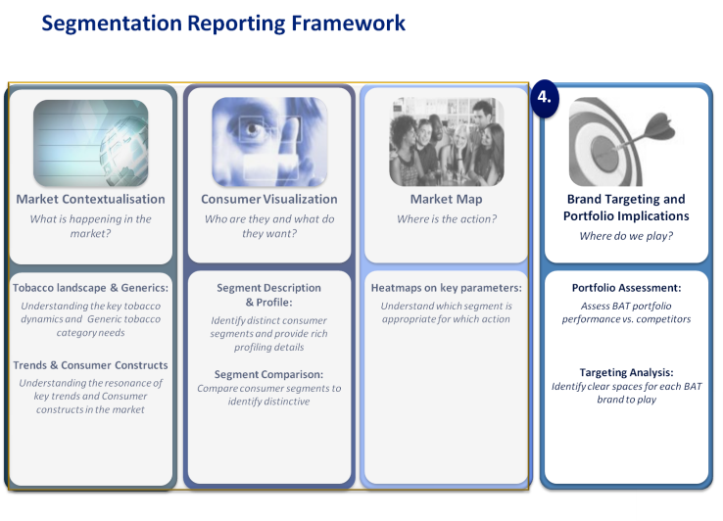

### Market Contextualisation:

Market contextualisation is a natural starting point to review the market with a forward looking lens by understanding smoker behaviour, key Consumer Trends and Constructs

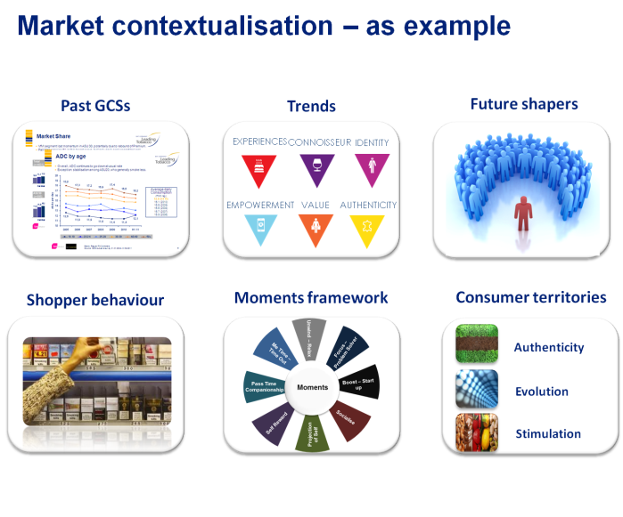

### Consumer Visualization

**Need States:**

The segmentation process starts from creation of the Need States that exist in the market. The questionnaire includes a rich set of attributes that are related to category, product and brand needs. The respondent is taken through a choice modelling task where they choose from a random set of 4 attributes always the most important and least important. These choices are then modelled to arrive at utilities for each respondent and need statement. Need States are created from the utilities by using Latent Class Clustering method. Each need state will be then described in terms of the category, product and brand needs. In addition to this each Need State is profiled by looking at the list of unmet innovation needs.

The number of Need States for a market will vary depending on the diversity of the market and the sophistication of the consumers. Typically 3-5 need states are identified within a market however each market will be unique in this sense.

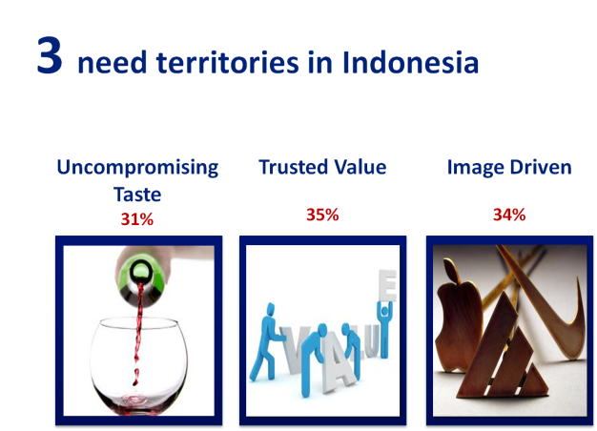

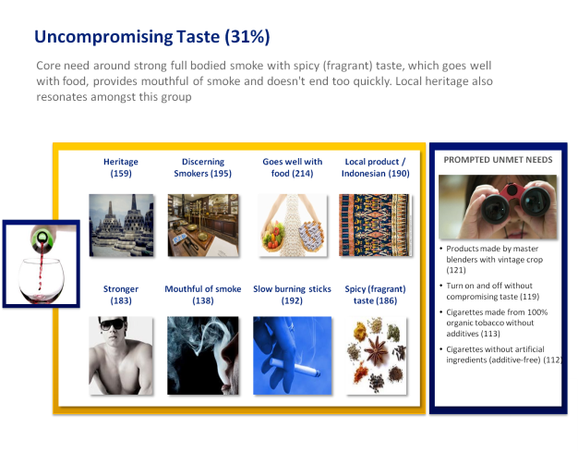

**Consumer typologies:**

In this part the respondents are clustered with the Latent Class technique based on their attitudes, behaviour, lifestyle and demographics to form consumer typologies. Whereas the need states describe what consumers want from the tobacco category – the consumer typologies are a broader indicator of these people as holistic consumers.

Just like the need states – the number of Consumer Typologies within a market will vary and may change over time. Typically 3-5 Consumer Typologies are identified but the number is unique for each market.

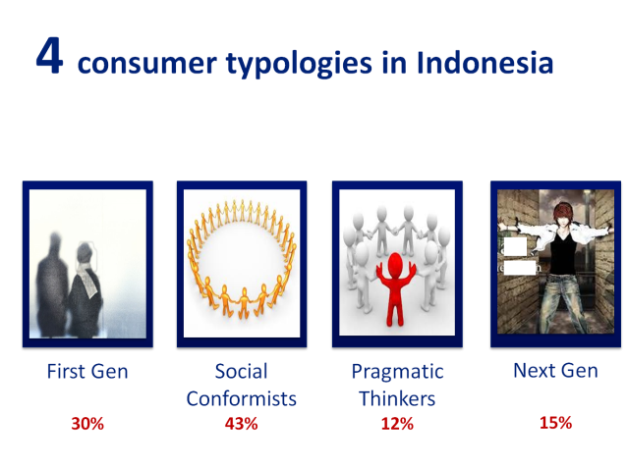

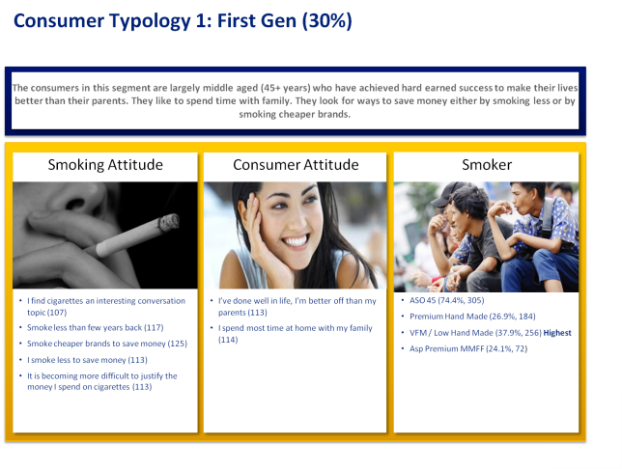

**Intersections and Segments:**

Once we have the Need States and the Consumer Typologies these two are crossed to arrive at the unique and targetable segments in the market.

The segments are then quantified in terms of smoker share and volumes to identify their size in the market. The number of final segments depends on the variety and complexity of the market – typical outcome would be somewhere around 9-12 segments but this is unique for each market.

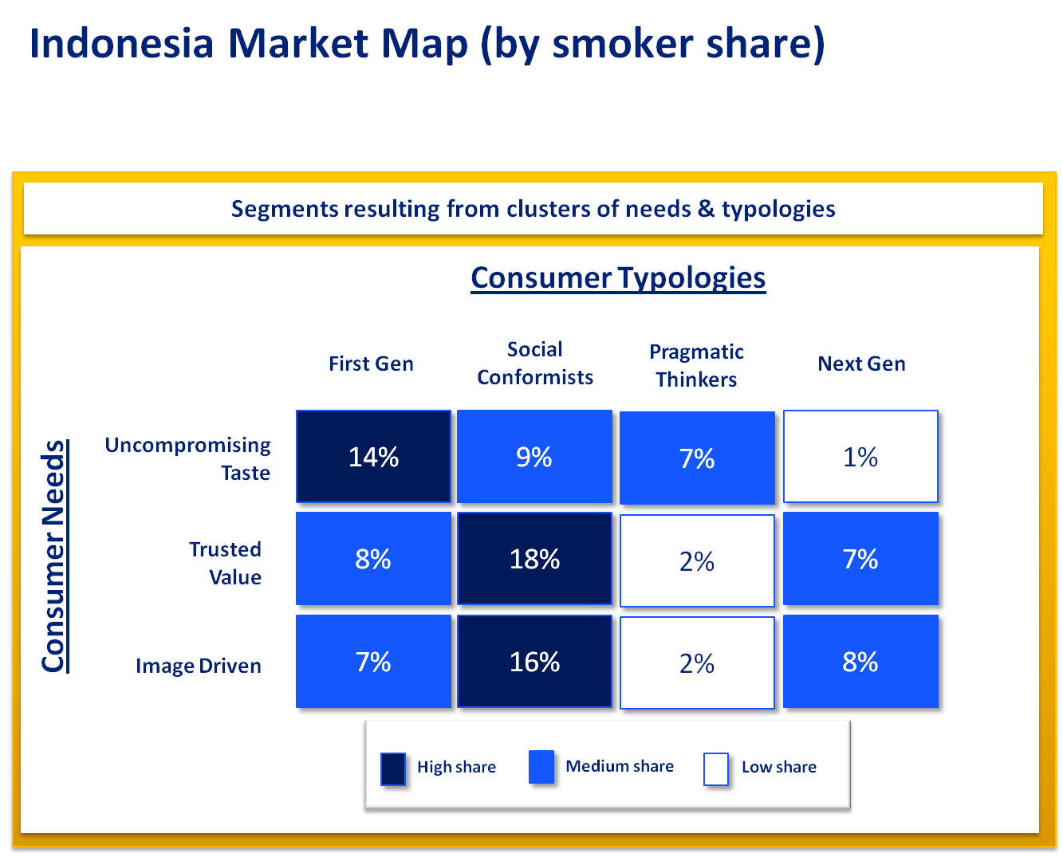

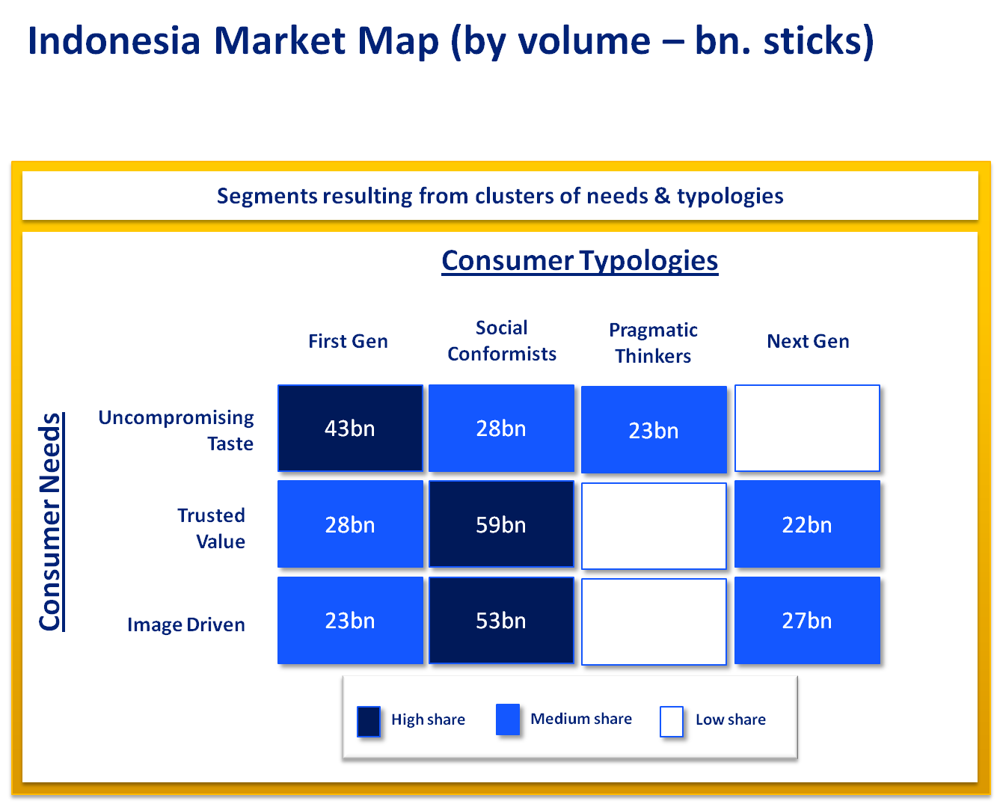

Each segment is then described in terms of the discerning characteristics of needs and consumer types.

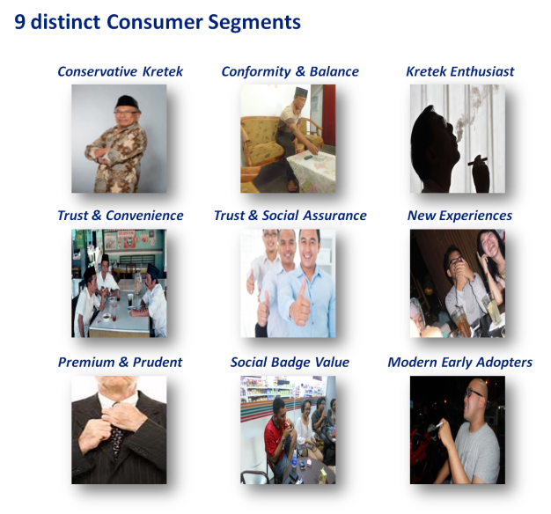

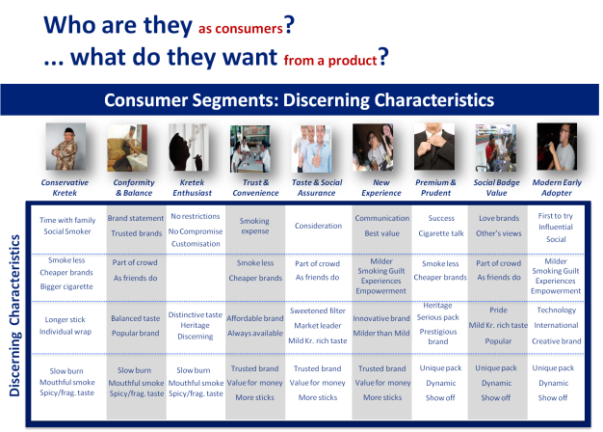

Furthermore each segment is profiled in detail in terms of needs, attitudes, demographics, category usage and behaviour.

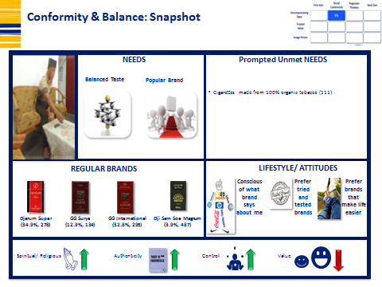

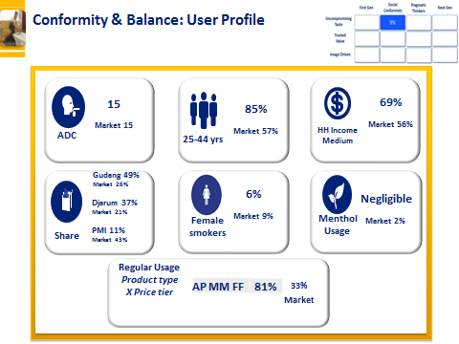

### Market Maps

The next step is to review the potential and significance of each segment against a list of key consumer groups and the market through market heat maps. Heat maps will be created for key segments like contestable space heat maps, price heat maps etc.

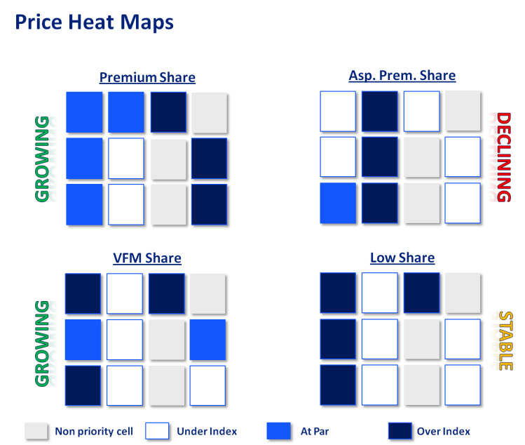

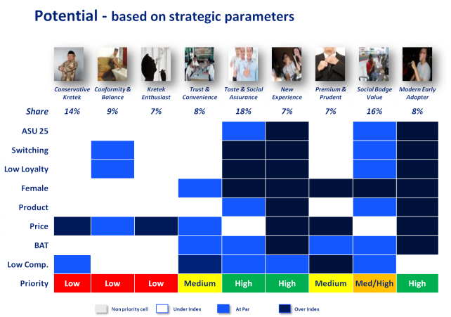

### Brand Targeting and Portfolio implications:

After the segments have been created and profiled the next step is to review how the brands in the market behave against the segments. This will be done via:

* *Brand Fit and Brand Equity Analysis*
* *Brand Discriminator Analysis (BDA)*
* *Brand Interaction & Usage Analysis*

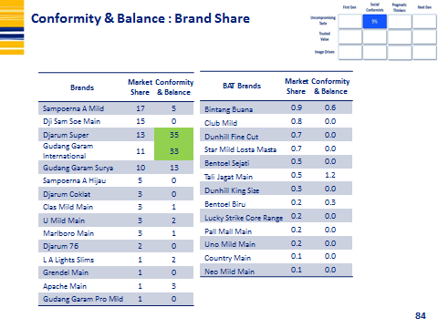

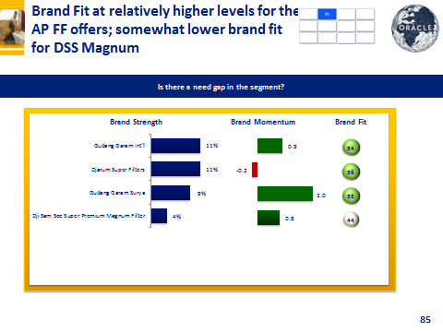

**Brand Equity Analysis:**

There are two equity scores calculated within the Segmentation study as part of Brand Equity Analysis: the *Brand Strength Score* and the *Brand Momentum Score.*

The Brand Strength Score is a measure of the brand’s current strength in the mind of the consumer. The Brand Momentum is a forward looking indicator that measures whether the brand is primed to grow share in future.

|  |
| --- |
| **Key questions and attributes required for Brand Equity** |
| * Spontaneous Awareness (Top of Mind) |
| * Brand Consideration * Usage – Ever Tried/ Regular/Occasional/Substitute/Previous * Bought in Last 10 purchases * Share of Past 10 purchases |
| * 6 attributes statements asked in Association Grid format   + *Appeals to you more than other brands*   + *Is a brand for someone like me*   + *Is a brand that is setting the trends*   + *Is a brand that meets my needs*   + *Offer something different to other brands*   + *Is a brand that I have a higher opinion of* |

Brand Strength Score Definition and Calculation:

The *Brand Strength Score* represents the strength of the brand in the mind of the consumer and is a measure of predisposition towards the brand. It is measured as a *“share of equity”* to conceptually represent the share that each brand would get, if the brands were competing only on equity and all other in-market activation factors were equal.

The Brand Strength Score is calculated as a weighted sum of Top of Mind Awareness and the six equity dimensions; the weights are unique to each market and are established based on a regression against Brand Consideration. The weighted sum of metrics for each brand is re-calibrated for each individual so that they sum to a 100 across all the brands, representing the “share of equity” score. Given that the BSS is computed at respondent level, it can then be aggregated to any level; for example, to represent the equity of brands in each segment to assess attractiveness of segment for the brand.

The Brand Momentum Score Definition and Calculation:

Brand Momentum score represents whether the equity of the brand is strong enough to prime the brand for future growth. It is a score calculated based on the comparison of Brand Strength Score to the brand’s market presence (as indicated by Bought in Last 10). The Momentum score for a brand is bigger if the brand has more equity (BSS) than expected, given its size of presence in the market. It suggests that the brand has potential to grow if it can remove marketplace barriers of purchase.

The Momentum Score can be computed at market level or for each relevant segment. It is best interpreted as a probability of share growth on a relative basis by comparing across brands.

**Portfolio Implications:**

Finally a deep dive analysis will be done within each segment to identify opportunities and threats. This analysis should be done for each segment and considering the current BAT portfolio to understand if there are any gaps or opportunities in the market that are potentially interesting for us. After the segmentation work has been done the next step is to arrange a Portfolio Strategy Review and the deep dive analysis is a pre-requisite for a good portfolio discussion.

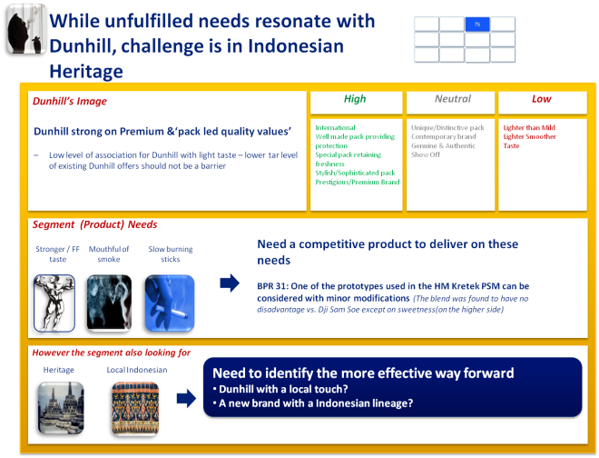

# Agency for Segmentation

The Segmentation study needs to be conducted with IMRB International who has the expertise to work with this methodology. The end market Kantar co-ordination team will play a role in terms of contribution of local market knowledge. The methodology is BAT proprietary and fully owned method.

Fieldwork can be administered by any agency chosen by the end market that is part of the official supplier scheme. When selecting the FW agency for the study please ensure that they have the technical capabilities to administer the interview with CAPI and sufficient capacity to handle the amount of interviews needed. Prior experience with tobacco research and large scale studies such as GCS or CBC are recommended as the segmentation questionnaire is relatively long.

To get started – please contact your IMRB International representative and indicate to them that you want to conduct the new segmentation study. The first step is to have a kick-off discussion to scope out the project and to discuss the different options and timings.